**CURRICULUM VITAE**

Uladzimir Yeudakimovich

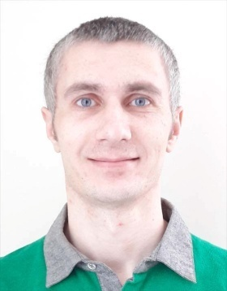

email [uladzimir.yeudakimovich@gmail.com](mailto:uladzimir.yeudakimovich@gmail.com)

site [https://uladzimir-yeudakimovich.ml](https://uladzimir-yeudakimovich.ml/)

phone +375 33 3344201

Personal Profile

Junior front-end developer with experience of creation single page application and progressive web application.

Responsible and highly trustworthy with analytical, problem solving and troubleshooting capability. Results oriented and customer focused, with excellent relationship management skills.

Self-motivated and able to work to own initiative, persistent to work under pressure, flexible with the ability to juggle priorities effectively, ambitious to drive the career forward and willing to learn.

Qualifications / Education

* Military academy of Republic of Belarus, Degree: engineer 2001-2005
* Academy of Public Administration, Degree: public administration and economic 2015-2019
* The Rolling Scopes School: front-end development 2017-2018

Languages

* English: B1 level
* Russian: native speaker

IT Skills

* Angular
* Bootstrap
* JavaScript
* REST
* Ajax
* jQuery
* Git
* webpack
* mocha
* SASS and LESS
* HTML5 and CSS3

Employment History

Front-end developer, IT Shark Ltd, Minsk

(July 2018 – Present)

Achievements and responsibilities:

* Creating application on Angular 6 with Bootstrap 4
* Working with REST API
* Creating application using JavaScript and jQuery
* Interaction with back-end

Front-end developer, Freelance Web Development, Minsk

(September 2017 – July 2018)

Achievements and responsibilities:

* Creating adaptive and interactive pages by layout
* Optimization web-pages
* Working with REST API

Military officer, Ministry of Defence , Minsk

(July 2005 – September 2017)

Achievements and responsibilities:

* Installing and configuring software
* Organization of a network and electronic document circulation
* Work with office equipment
* Organization of communication
* Encryption
* Management of staff
* Conducting classes